Daniel Fryer
Assignment 4.2 mySQL install
2/5/2026
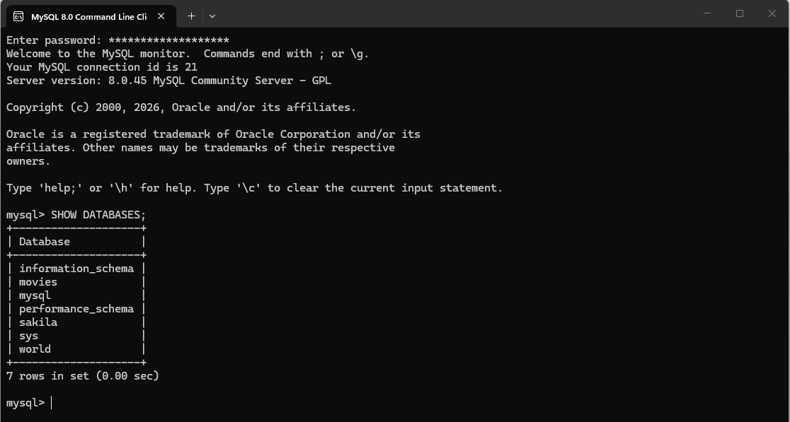

1. Upper is used to make the string characters all to become upper-case. This can be beneficial when doing compares if you don’t care if the user had used upper or lower case.
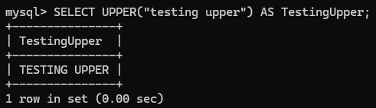

2. Replace is used to change characters from a string to another character. This can be used if for some reason you forgot to scrub the data from the app side before being written to the database you can remove characters you don’t want in the database.
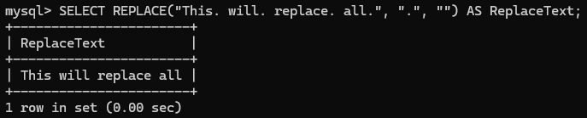

3. Concat function lets you combine two or more sets of information together to display it as one. This can be useful if you want to combine two columns like FName and LName to display a user’s First name and last name combined into one column.
